14.41: Let point 1 be where 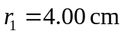 and point 2 be where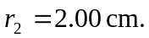 The volume flow rate has the value 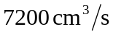 at all points in the pipe.
